**Practical NO. 8**

**App Development using Cloud Computing**

1. **Aim:** To develop applications using Google App Engine by using Eclipse

IDE

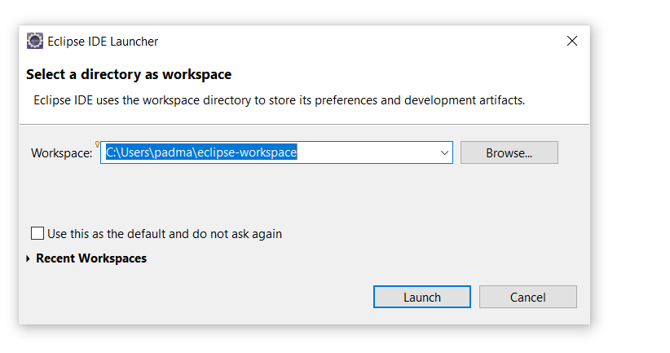

After Creating Workspace below screen will appear

Click on **HELP->Eclipse Marketplace**

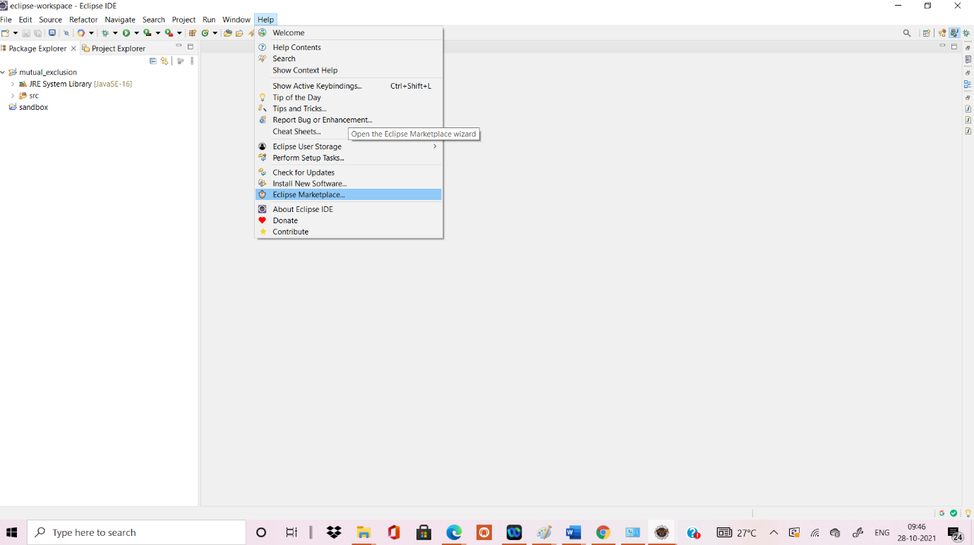

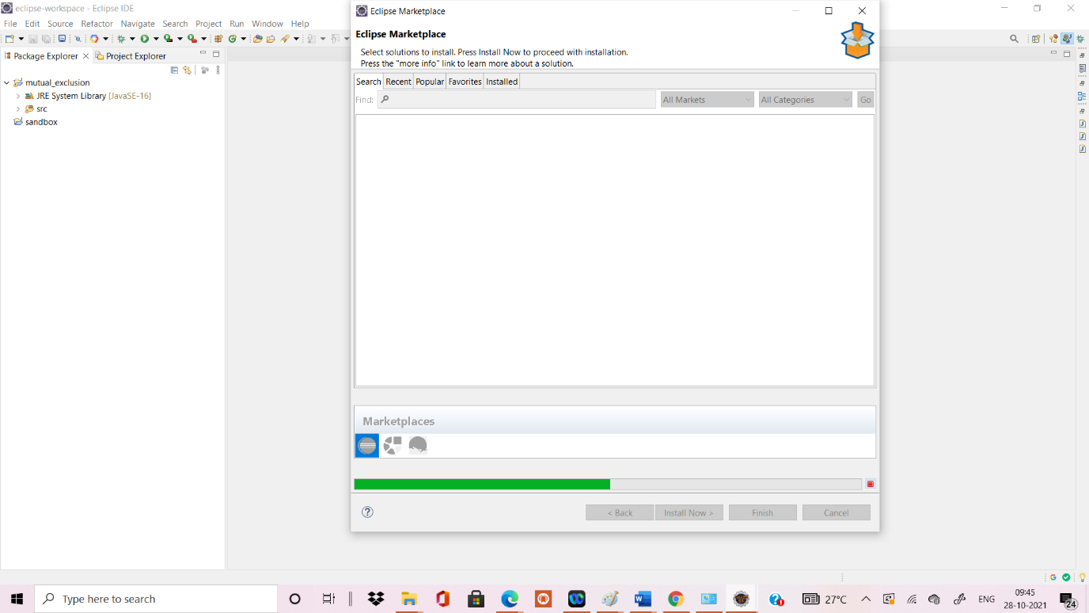

Once the Eclipse Marketplace window appear in search textbox write **google** click on enter

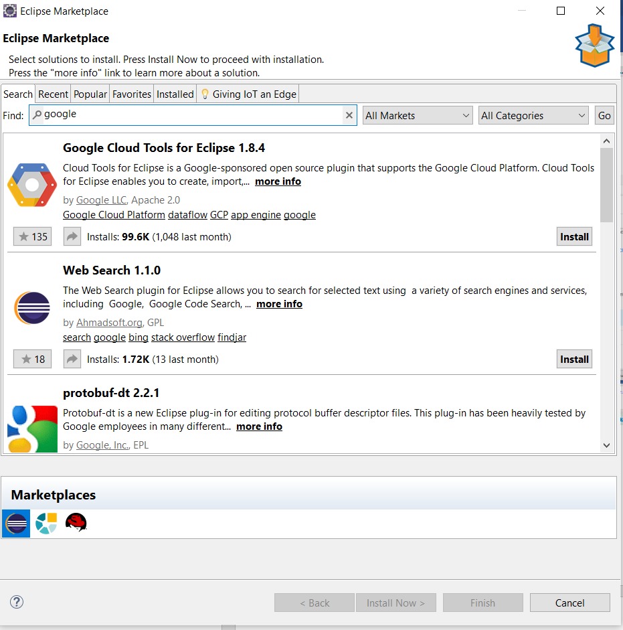

**Click on Confirm**

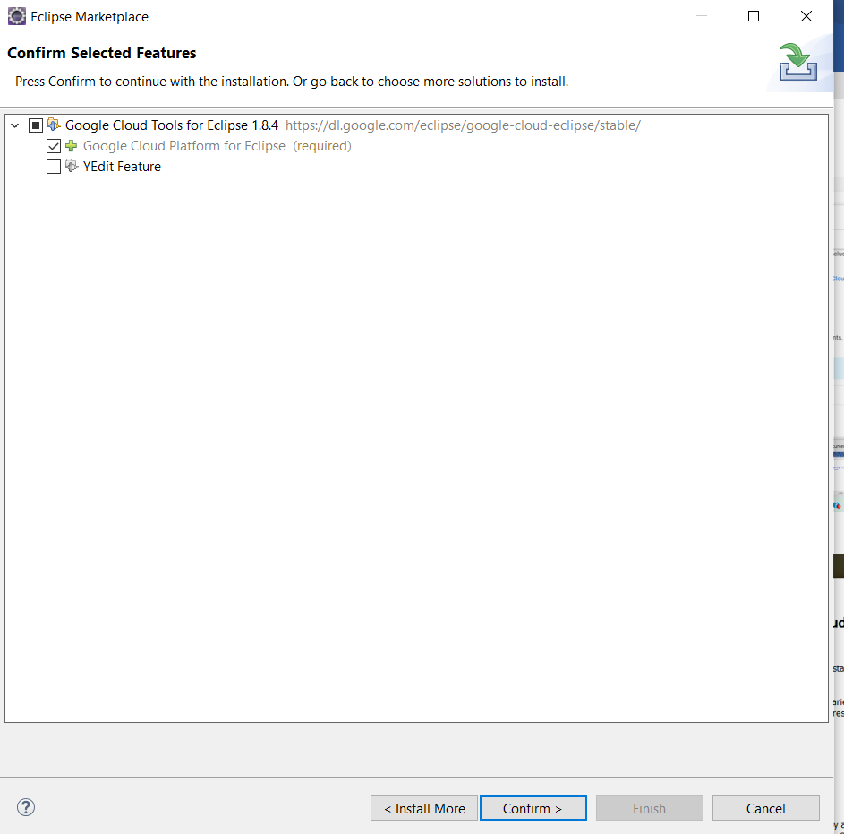

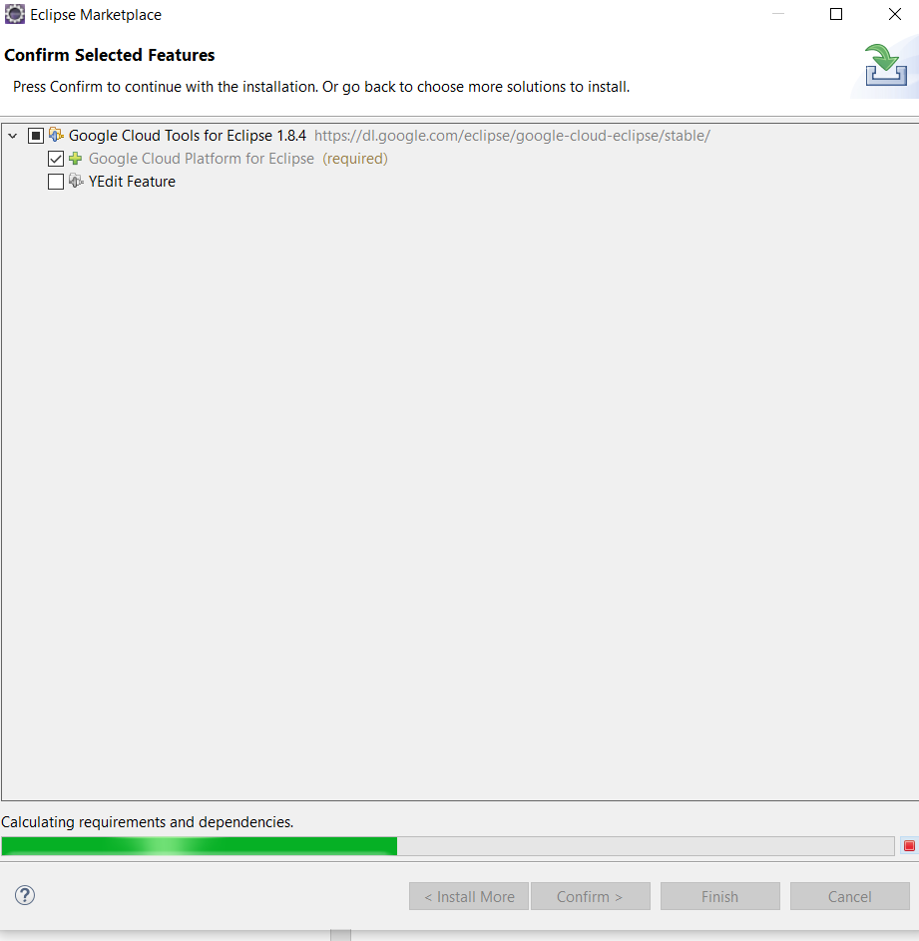

Once the below window appear click on **trust selected**

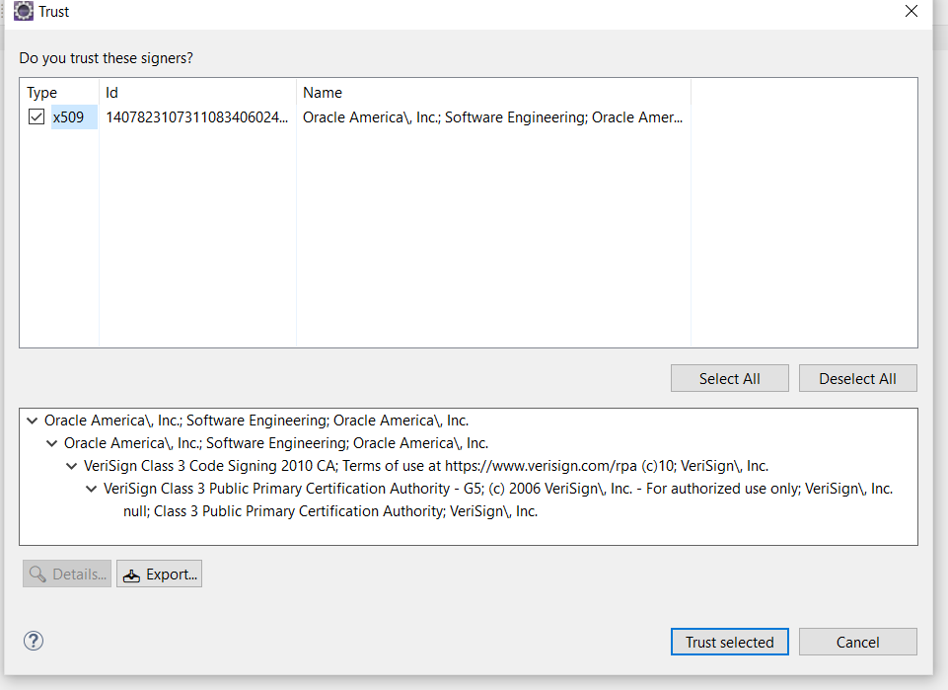

Click on restart now

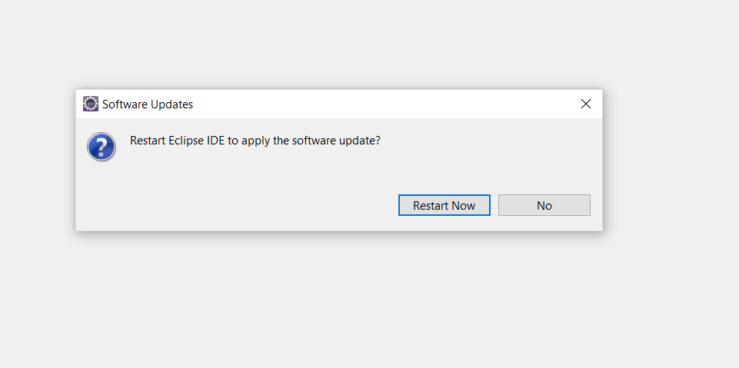

Below window will appear



Below window will appear **close the welcome page**

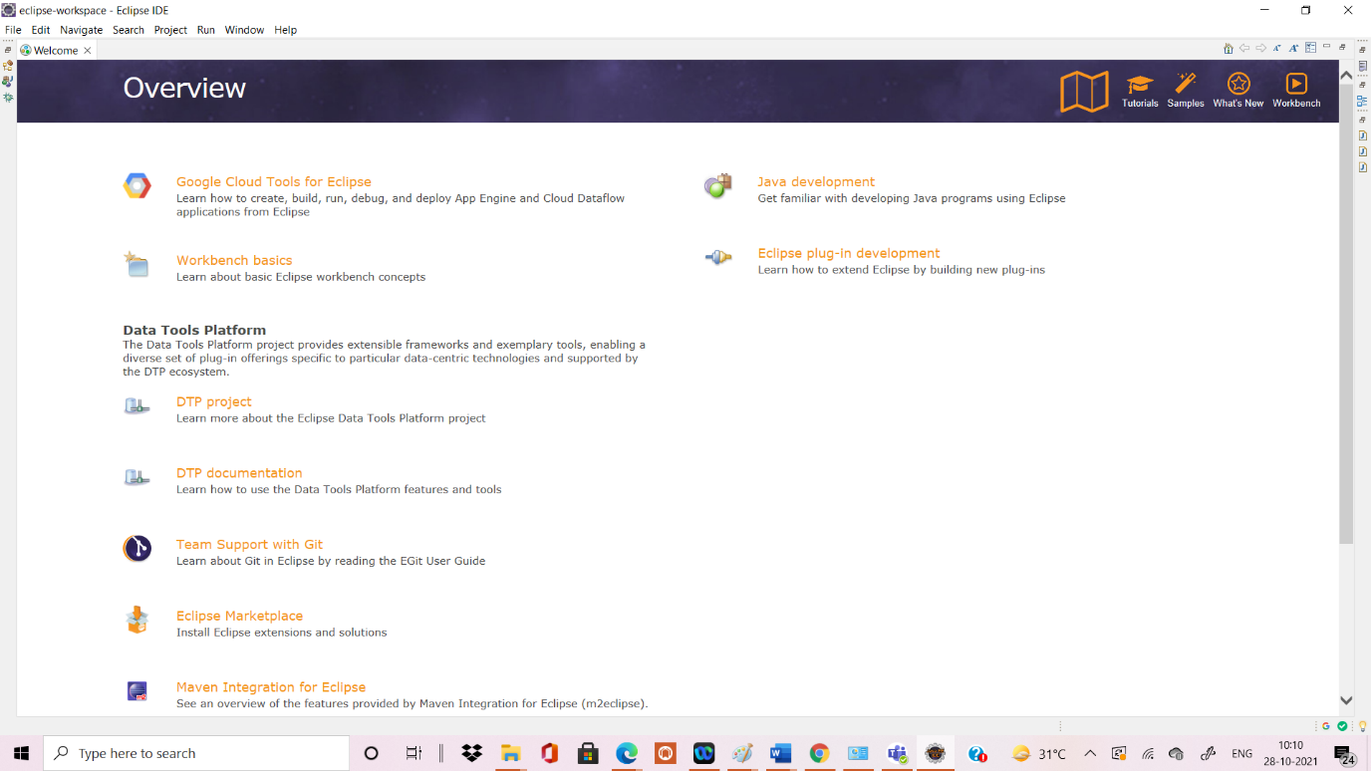

Once the eclipse window appear -click on WINDOW->PREFERENCES

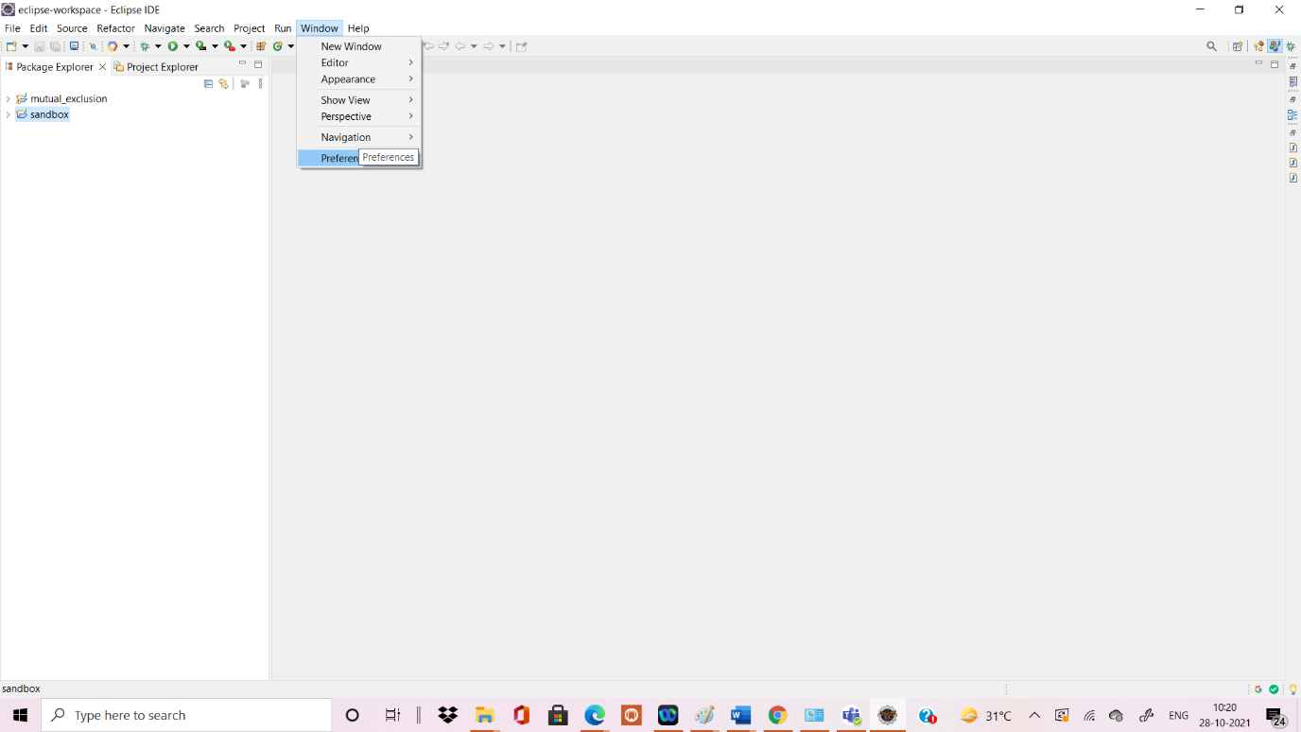

Below Preferences window will appear **SEARCH FOR GOOGLE**

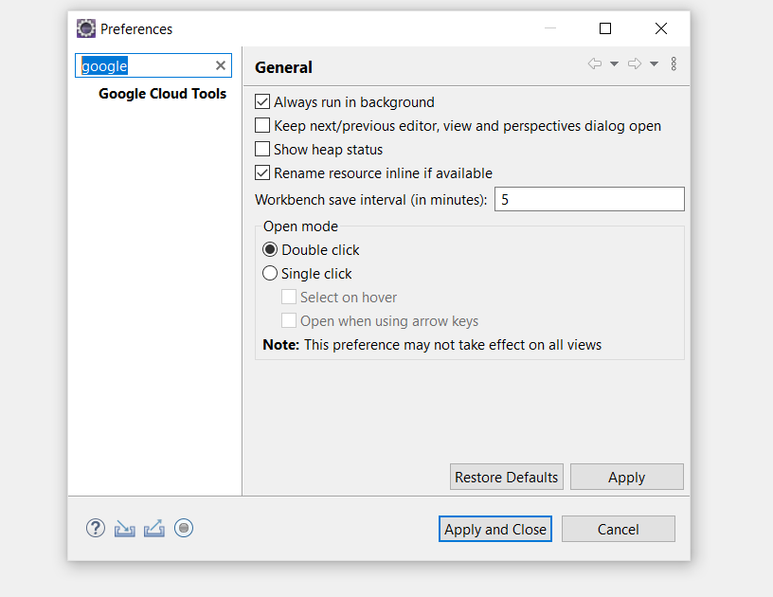

**Click** for **APP ENGINE JAVA COMPONENTS** and click on **APPLY AND CLOSE**

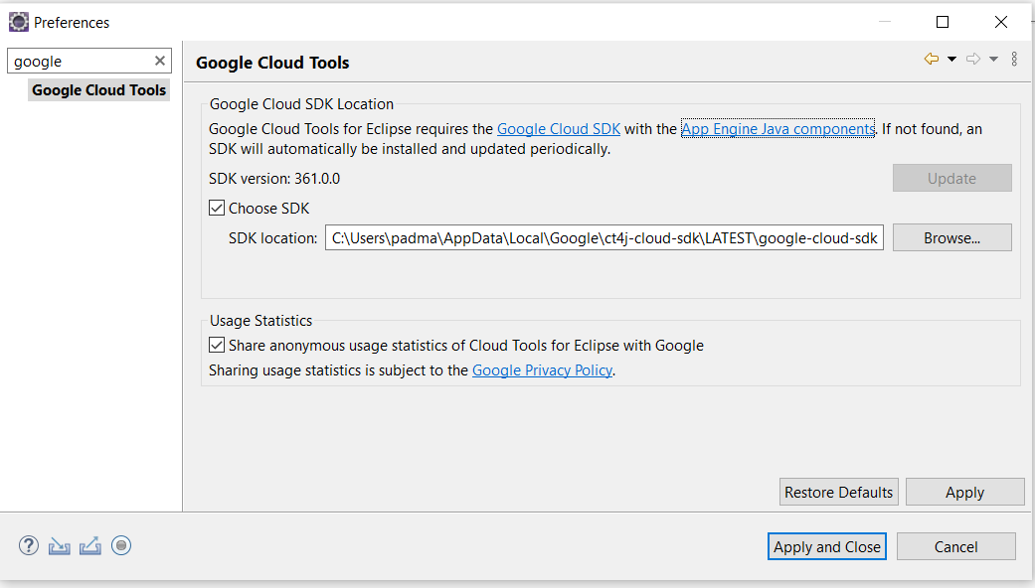

In Eclipse workspace  **click on dropdown ->Click ->Create New Project->Google App Engine Standard Java Project.**

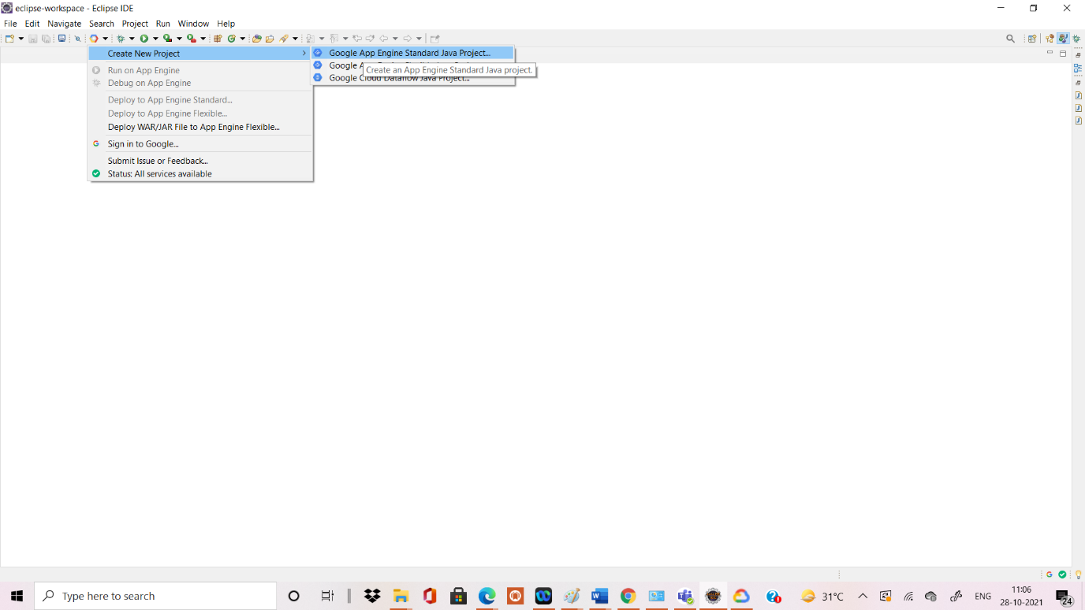

**Below screen will appear New App Engine Standard Project**

**Provide the Project Name & Java Package as mentioned below**

**Project Name: My SandboxProject**

**Java Package: com.gonevertical.server.sandbox**

**Click on Next**

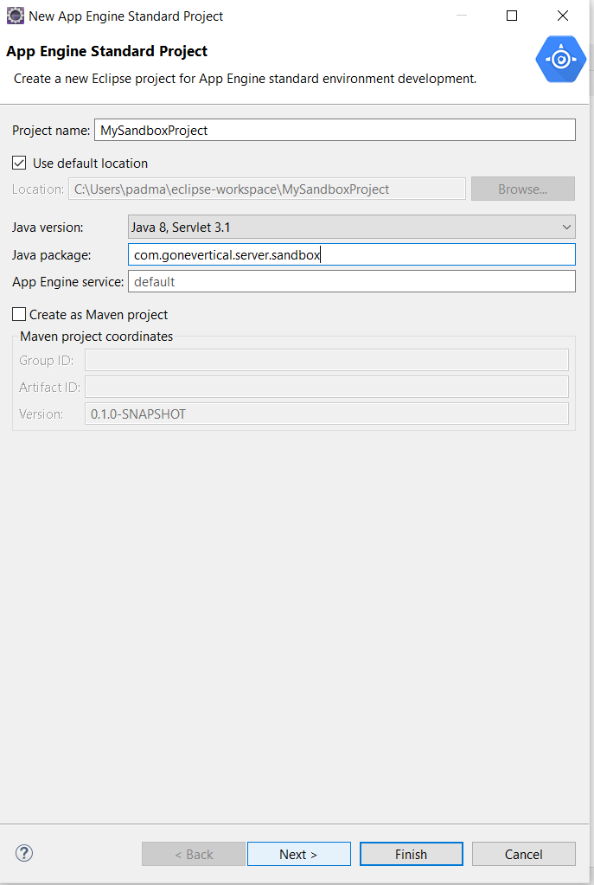

**Below screen will appear**

**FROM App Engine Standard Libraries**

**Select 1.App Engine API**

**Select 2.Objectify**

**3.Click on Finish**

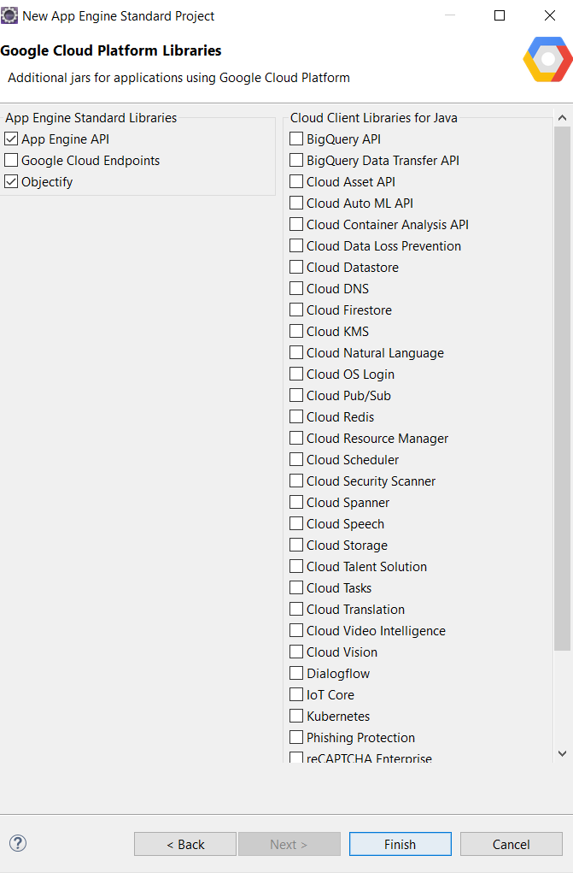

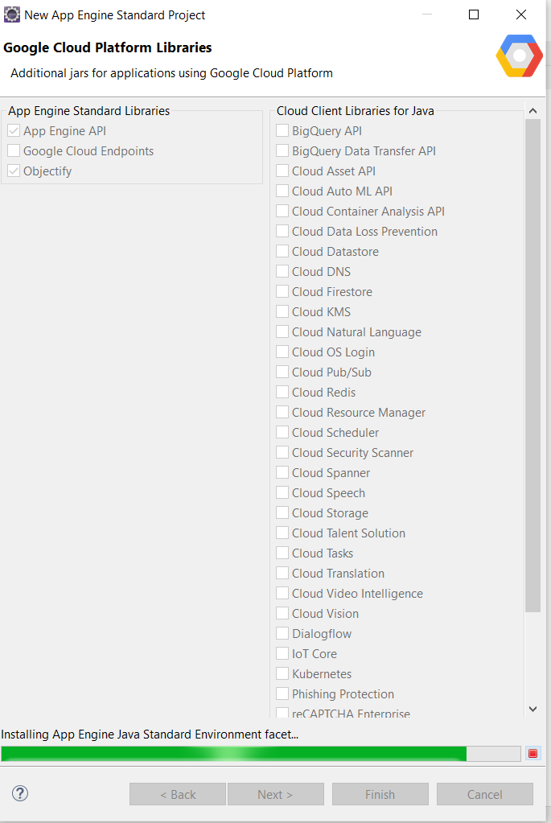

**Below Screen will Appear** **HelloAppEngine.Java**

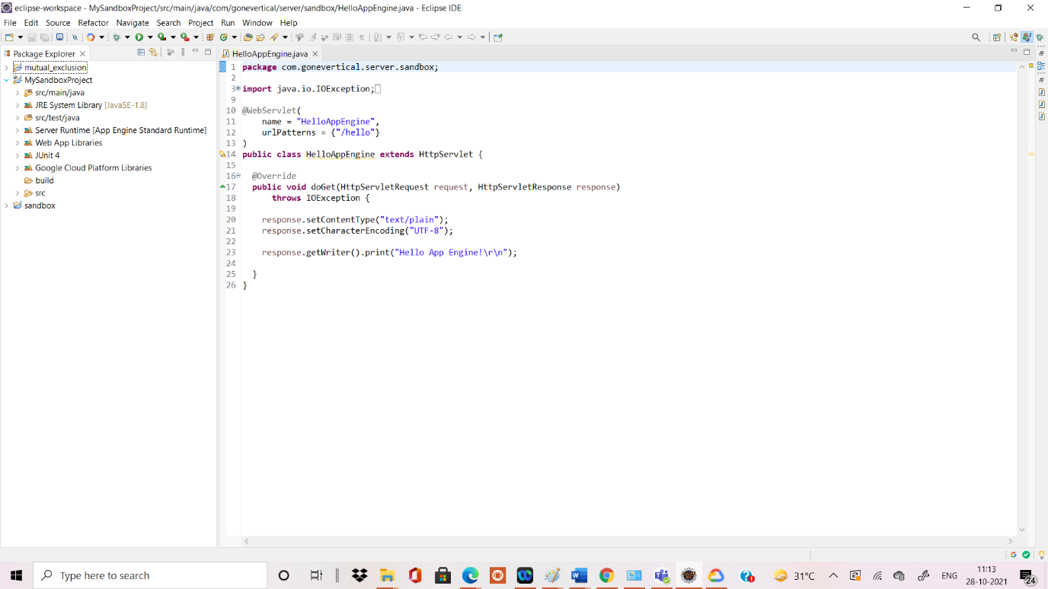

Go to **Window->Show View->Other**

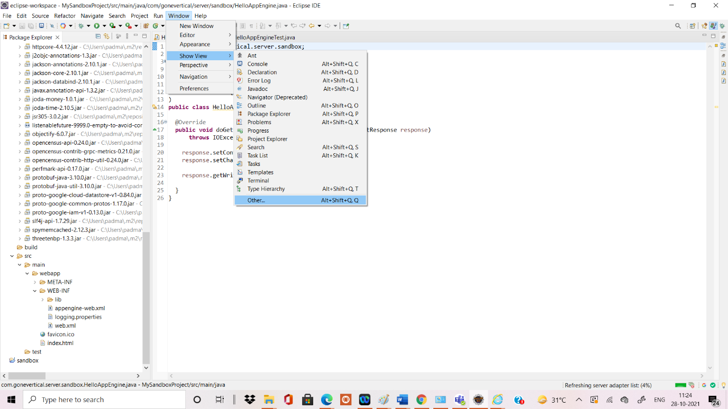

**After clicking on other below Screen of Show View will appear**

1. **Click on Server->Servers**
2. **Click on Open**

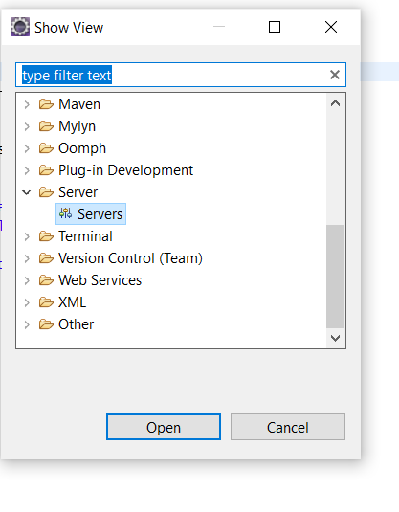

**Click on Window->Editor->Console**

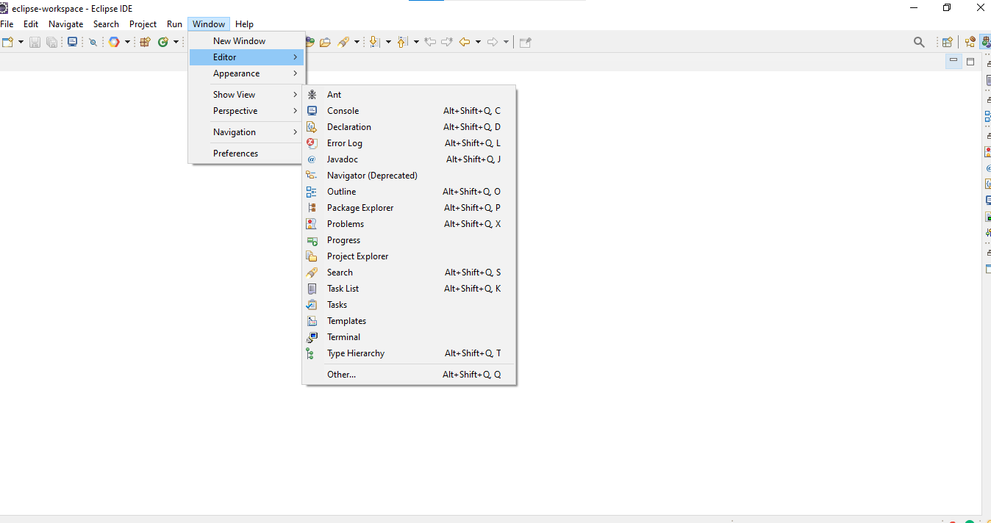

Once the **Console screen appear ->Click on Servers**

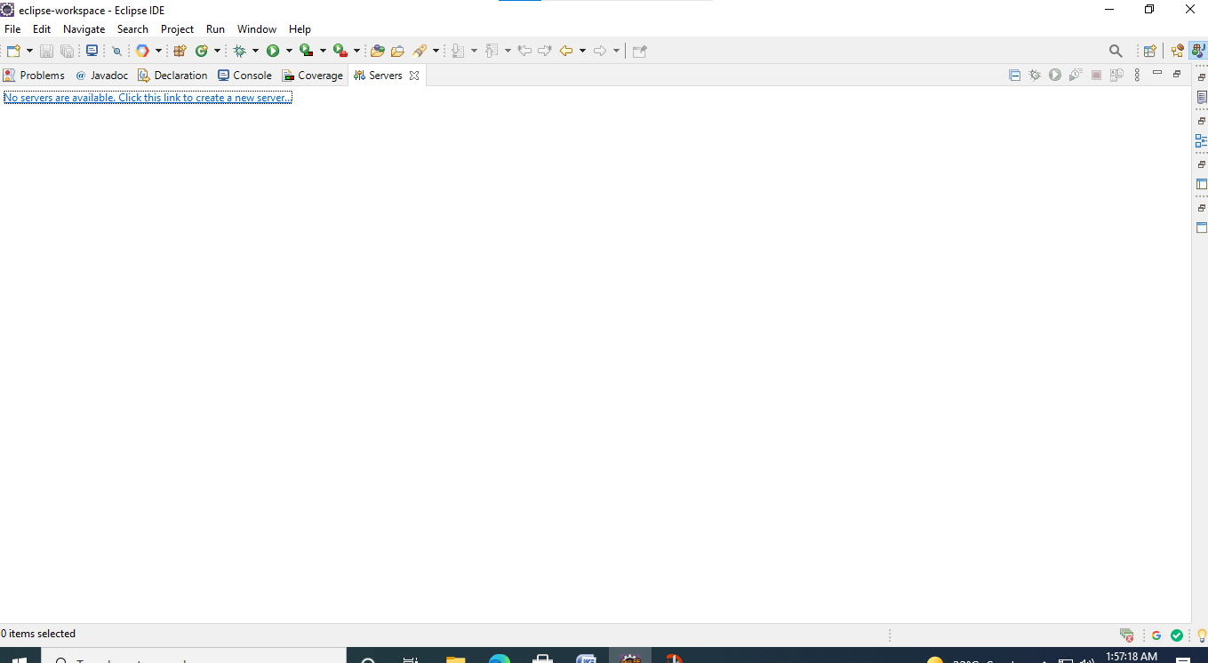

**Right click on server ->New->Server**

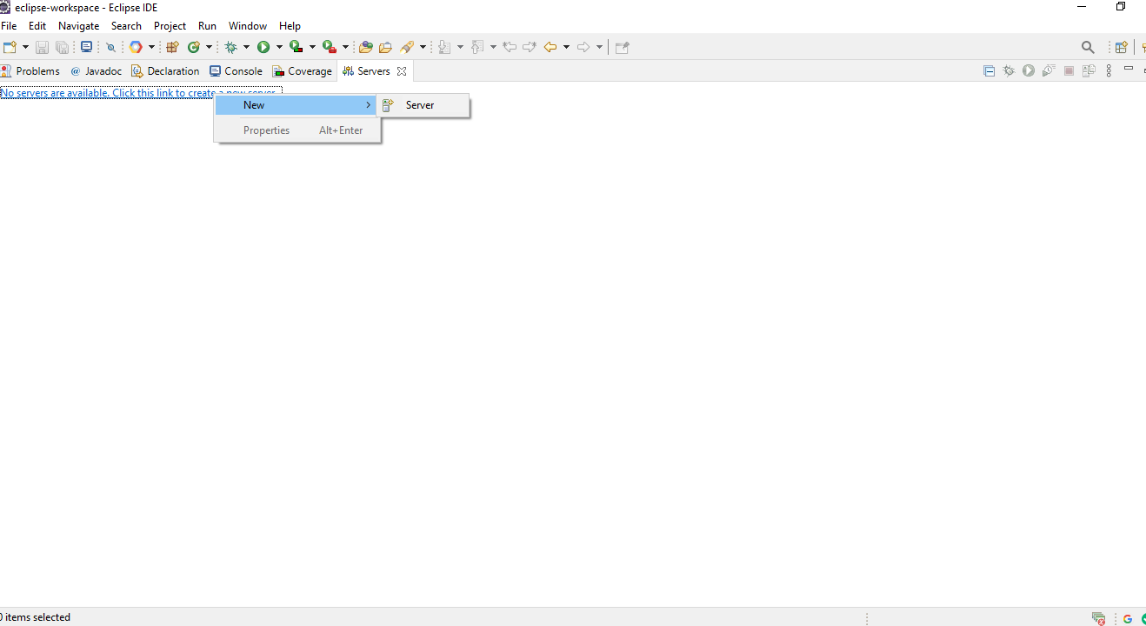

**To define a new server will below screen appear 1. Select App Engine Standard 2.Click on Next 3.Click on Finish** 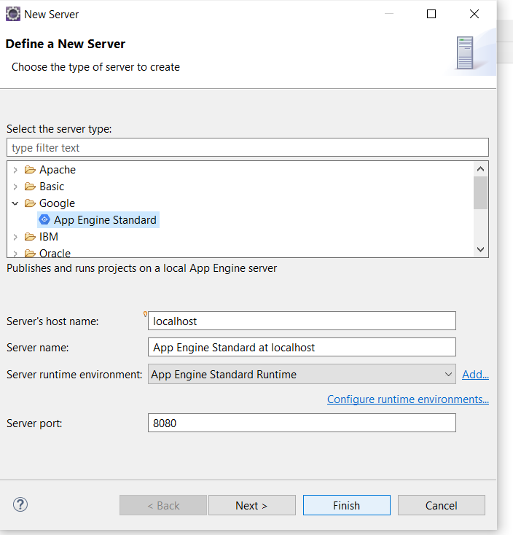

**Select from Available Project: MySandboxProject and then click on Add Button**

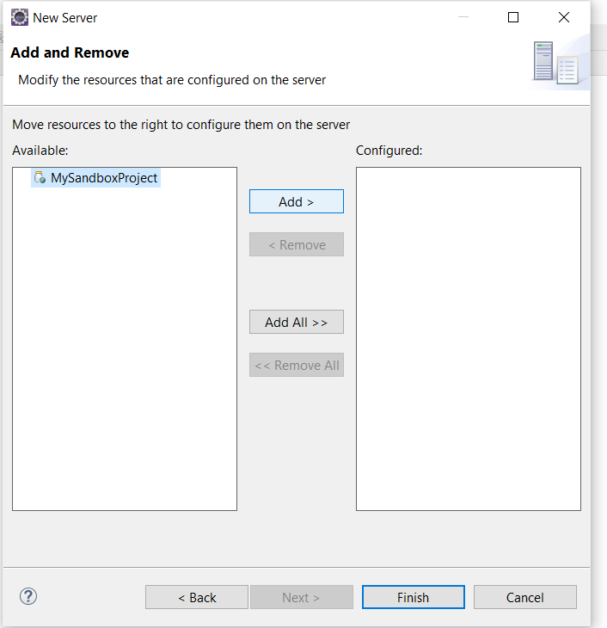

**After adding MySandboxProject in Configured then Click on Finish Button**

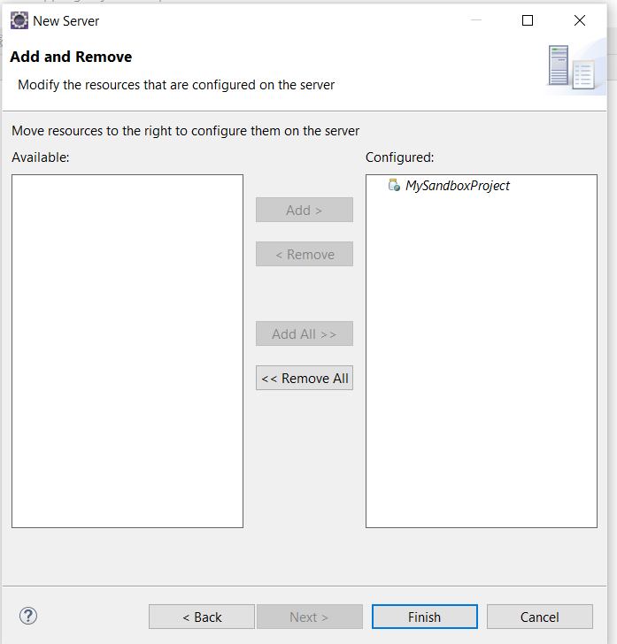

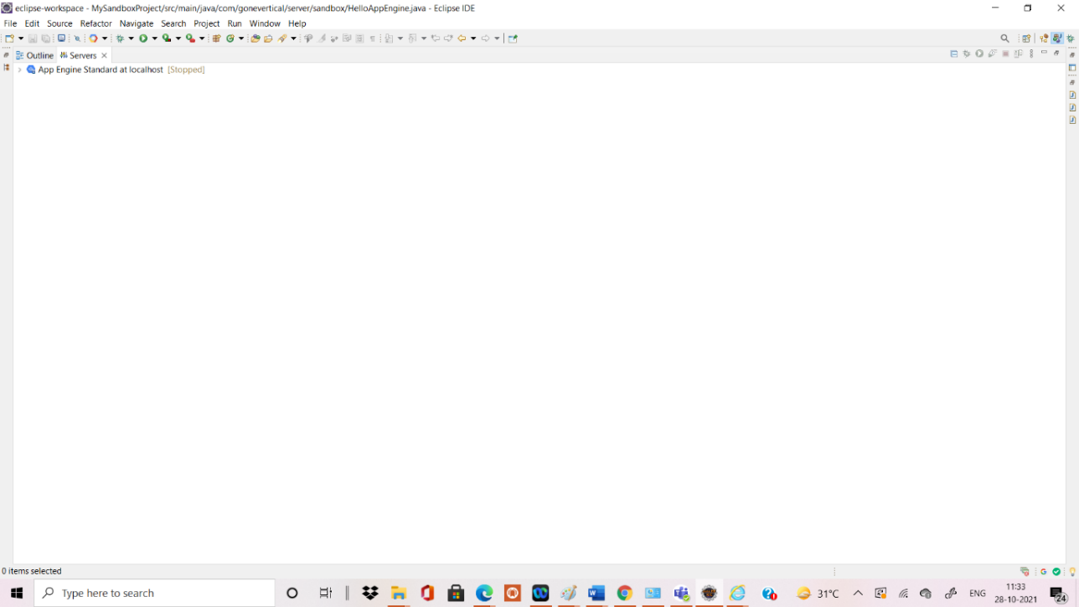

Click On App Engine Standard At localhost ->MySandboxProject

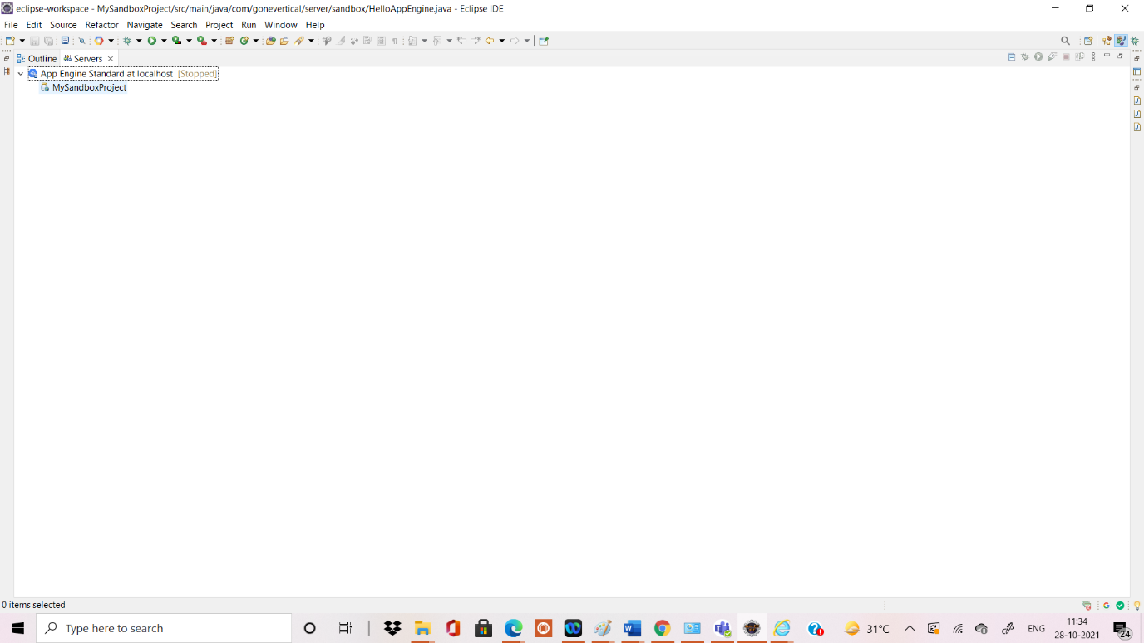

Right click on App Engine Standard At localhost->Click on Debug

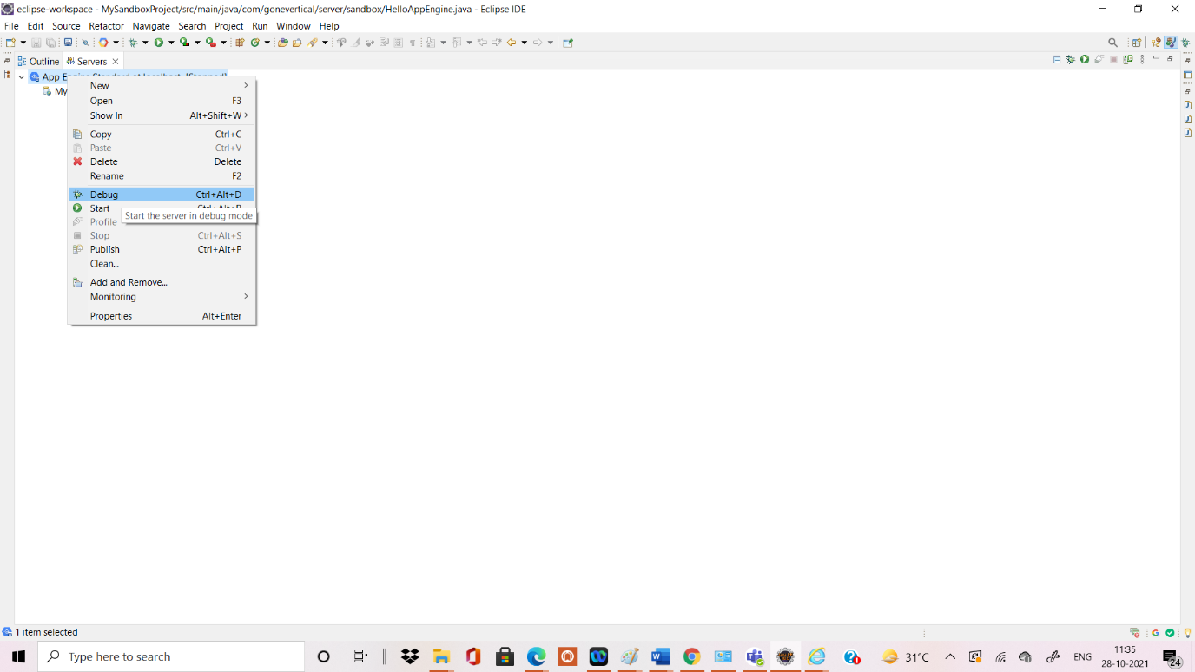

**Final Output Screen will appear**

